**Lab Assignment No. 04**

**Title: Find a procedure to transfer the files from one virtual machine to another virtual machine**

1. Download the Ubuntu VMDK image from https://app.vagrantup.com/bento/boxes/ubuntu-18.04
2. Download and install Oracle's Virtual Box https://www.virtualbox.org/wiki/Downloads

**Steps Launch new Virtual Machine:**

1. Open Oracle VM VirtualBox Manager

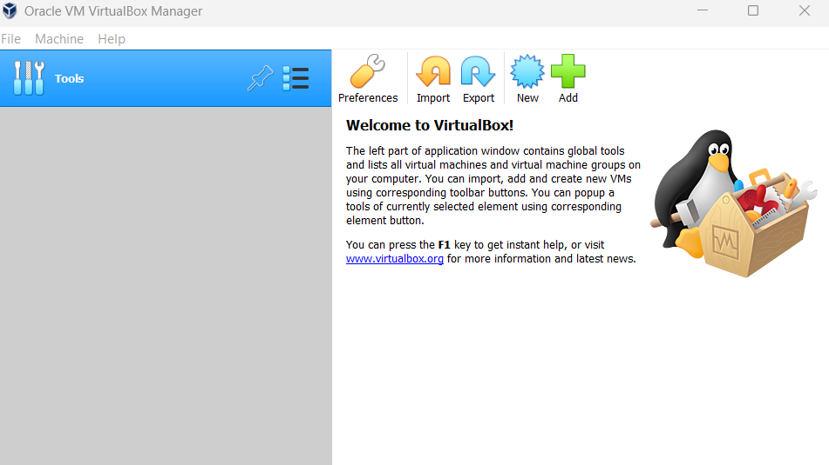

1. Click on new

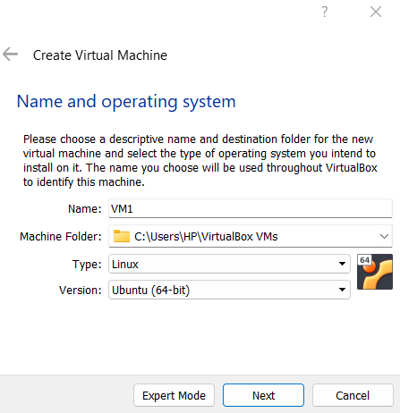

1. Select **Use an existing virtual hard disk file**

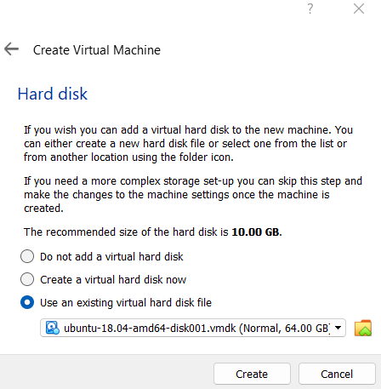

1. Now add NatNetwork

File → Preferences → Network → Ok

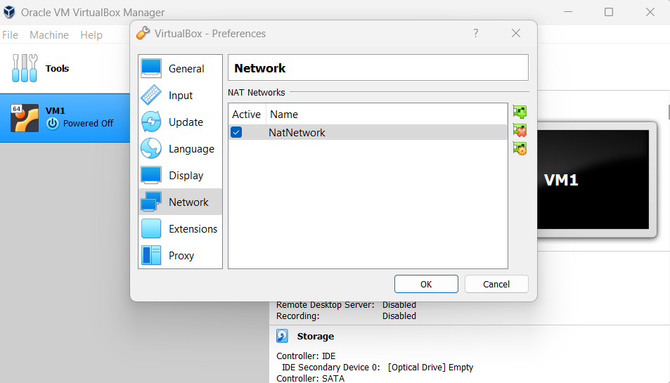

1. Go to VM Settings → Network → Attached to → Nat Network → Ok

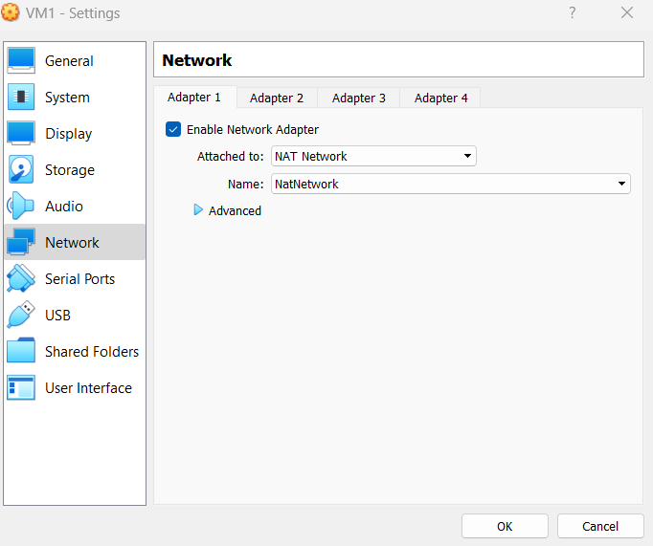

**Repeat the same process and create VM2**

**Pass data between Virtual Machines:**

1. Start VM1 and log in using the **vagrant** username and password

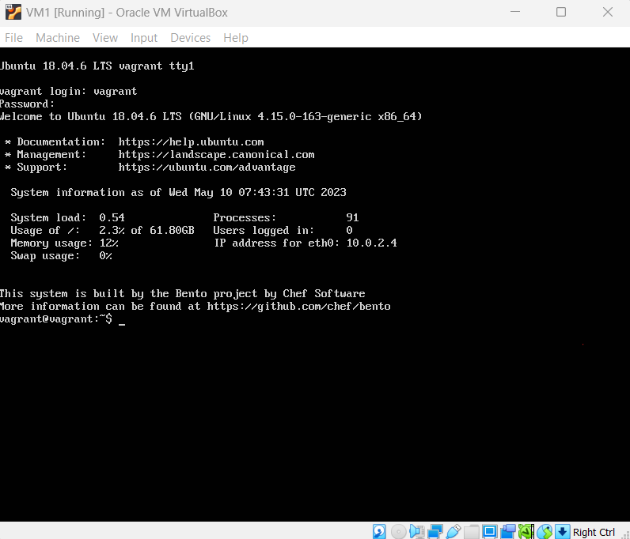

1. Create a file using **touch myfile.txt**
2. Write data in a file using **nano myfile.txt**
3. Run **ifconfig** command it will give the address of the system in this case address of VM1 is **10.0.2.4**
4. Start the VM2 login into it and get its address using the **ifconfig** command **10.0.2.5**
5. Run **scp myfile.txt vagrant@10.0.2.5:/home/vagrant** command in VM1

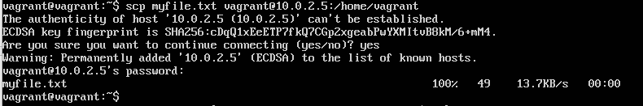

1. Run **ls /home/vagrant** in VM2 and check myfile.txt is present there and see the content of the file using the **cat myfile.txt** command

